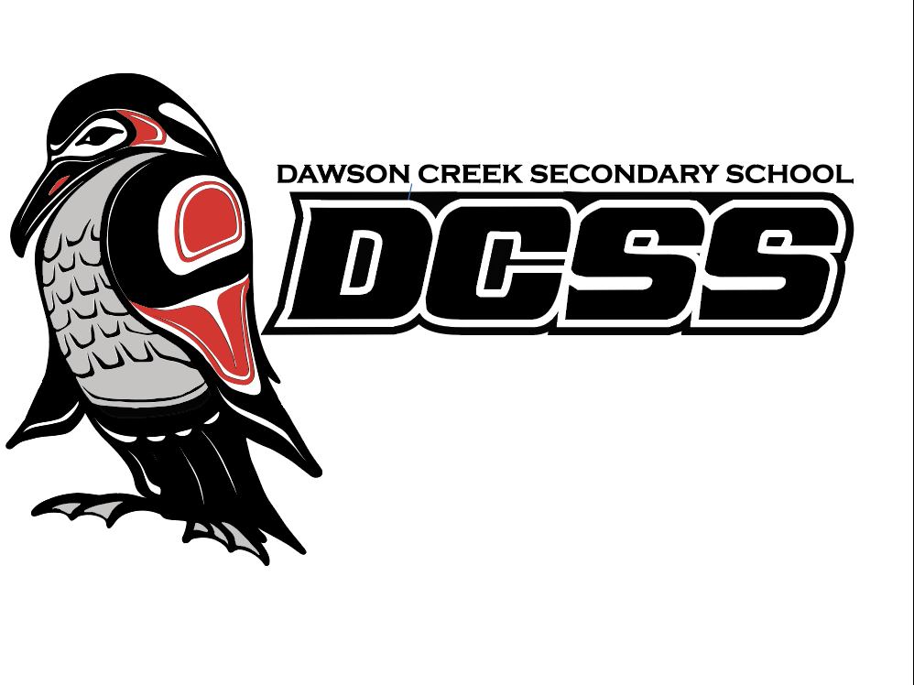
South Peace Campus
2025 – 2026

Student Code of Conduct
https://www.sd59.bc.ca/schools/dawson-creek-secondary-south-peace

10808 – 15th St.,
Dawson Creek, BC
V1G 3Z3
(250) – 782 – 5585

DCSS CODE OF CONDUCT

Members of School Community
It is expected that all members of the school community (staff, students, parents and guests) will adhere to the District code of conduct and will:
- Respect the rights of others to feel safe and secure in all facilities;
- Respect the positive learning environment in schools;
- Respect the property of others – private and public in all environments;
- Respect the legitimate authority of the school principal and staff;
- Respect the diversity of the school community
- Respect the non-smoking nature of district schools and property (prohibiting the use of tobacco, cannabis/cannabis products and vapour products);
- Not threaten, harass, intimidate or assault, in any way, any person within the school community and in all district environments; (ref: Policy 4390 Bulling and Harassment in Schools)
- Not be in possession of weapons, dangerous articles, alcohol, cannabis/cannabis products or illegal drugs while in school or at school functions, or on any school district property;
- Maintain confidentiality of all work related information
Students and parents shall be informed of the School’s expectations for student behavior within the school, on the school grounds and during school related activities. We consider these expectations to be reasonable and fair and reflect the conduct desired for individuals within a successful school community.

At Dawson Creek Secondary School – South Peace Campus all students have the right to:
- be treated with dignity, respect and fairness by other students and staff regardless of their sexual orientation, gender, race, religious beliefs, color, ancestry, place of origin, political belief, family status, physical or mental disability.
- learn in an environment free from physical, emotional and social abuse;
- privacy and their own personal spaces;

THREE R’S FOR DCSS Students ~ AN ONGOING EXPECTATION!

BE READY ~ Be prepared for class and ready to learn. Assignments and homework are completed and handed in on time. Work is done to the best of one’s ability. On-task. Participates in activities, pays attention and makes the effort to do well.

BE RESPECTFUL ~ Attitude is positive, kind and considerate. Care, accept and encourage classmates and friends. Be polite, understanding and thoughtful of others.

BE RESPONSIBLE ~ Behavior is appropriate and cooperative. Solve problems in peaceful ways. Take responsibility for actions and lead by example in class and around the school. Help to create a safe and positive environment at DCSS.

It is expected that Dawson Creek Secondary School – South Peace Campus students will:
- be aware that student behavior outside of the school environment that negatively affects the safe and orderly operation of the school will be addressed as a school related issue;
- recognize and respect the rights of all students to learn and teachers to teach;
- respect the authority of all adults affiliated with and employed by the school;
- not possess any weapon or dangerous goods in the school or on school property;
- refrain from inappropriate use of school Internet and cyber networks.
- use technology (such as cell phones, tablets, etc.) in a responsible manner.

Students shall be responsible and accountable for their behavior and conduct:

- while involved in school sponsored or related activities;
- while on school property;
- during breaks on or off school property;
- while traveling to or from school;
- beyond the hours of school operation if the behavior or conduct detrimentally affects the climate and efficiency of the school.
- while interacting with others in cyber space (places like Facebook, TicTok, Snap Chat, etc.)

All students are responsible for following behavior expectations. A variety of responses will be administered for failure to comply with expectations taking into account the student’s age, maturity and circumstances:
- Whenever possible and appropriate, consequences will focus on ones that are restorative in nature.

- Principles of fair treatment and the capacity to evaluate each circumstance based on the individual circumstances, rather than arbitrary applications of rules

Considerations may apply to students with special needs who may be unable to comply with expectations due to having a disability of an intellectual, physical, sensory, emotional or behavioral nature.

BULLYING AND HARASSMENT

Assault, bullying or harassment in any form will not be tolerated in DCSS environments. Students will not discriminate against others on the basis of race, ancestry, physical or mental disability, color, ethnicity, religion, real and/or perceived sexual orientation, gender identity or expression, marital or family status, sex, age or for any other reason set out in the Human Rights Code of British Columbia. Neither will a student make gestures, publish, or display anything that would indicate an intention to discriminate against an individual or group, or expose them to contempt or ridicule.

DEFINITIONS ~

Conflict: is a disagreement or difference in opinion between peers who typically have equal power in their relationships.

Assault: a harmful physical, verbal or non-verbal attack, slur, or demeaning gesture directed against another individual or their property.

Bullying (including Cyber-Bullying): the recurring attempts to threaten, frighten, tyrannize, or intimidate another, including acts of aggression that are real or implied, verbal or non-verbal aggression, and/or social alienation where one individual attempts to exert their will or control over another person.

Harassment: to continuously trouble, torment, gesture or speak inappropriately toward another individual in a manner that causes discomfort to that individual.

Grounds for disciplinary action that could lead to a change of academic programming or suspension from school exist where a student has demonstrated unacceptable behavior:

- conduct which threatens the safety of students and/or staff;
- possession of a weapon that is dangerous to students and/or staff (NB. a ‘weapon’ is anything designed to be used to cause injury, threaten or intimidate another person);
- fighting or instigating a fight on the school grounds or property;
- possession of or reasonable suspicion of use of illegal drugs, alcohol or other illegal substances in school or on school property;
- theft;
- non-compliance of school and school district policies and regulations related to student harassment, smoking, student attendance and students’ rights and responsibilities;
- willful disobedience and/or open opposition to authority;
- use or display of improper or profane language;
- willful damage to school or other’s property;
- interfering with the orderly conduct of class(es) within the school and on school property (i.e. fire alarms)

ATTENDANCE

All absences from classes potentially affect the student’s capacity to achieve academic success in individual classes. We will not differentiate between excused or unexcused absences for the purpose of collecting attendance data. ‘Approved’ absences are absences approved at the school level for school related curricular and extra-curricular activities (there is parental involvement in the approval process). Classroom teachers

will be informed of approved absences in advance of the student missing class. Approved absences will be reviewed through the data collection process.

*Student athletes, in particular, must constantly inform their teachers, in advance, of the purpose of their absence(s).

Absence: A student who does not attend class will be marked absent.
*A student who misses more than 20 minutes of class time (25%), without approval, will be marked absent from the class.

Late: A student who arrives to the class within the first 20 minutes of class.

Absenteeism:

3 Unexcused Absences in a month – Classroom teacher connects with the student and parent/guardian to discuss attendance.

30% Unexcused Absences in a class – Classroom teacher refers student to SBT.

- An individual plan (and /or contract) will be created with the student and parent outlining specific next steps for the student.
  - NEXT STEPS may include:
    - A schedule review and potential removal from the individual class.
    - Recommendation of make-up time at the school where the student works to complete outcome work for the individual class.

Tardiness: ‘Lates’: Students are required to be in class on time. A warning bell rings prior to each class bell. The warning bell provides the students with time to prepare to be in class on time.
Students who are late for class miss key instructional components of the class and valuable learning opportunities. Late students disrupt the learning environment for both the classroom teachers as well as the other learners already in the room.

Lates will recommended to SBT at the discretion of the teacher.

- An individual plan (and /or contract) will be created with the student and parent outlining specific next steps for the student.
  - NEXT STEPS may include:
    - A schedule review and potential removal from the individual class.
    - Recommendation of make-up time at the school where the student works to complete outcome work for the individual class.

SAFE and CARING EDUCATIONAL ENVIRONMENT

Dawson Creek Secondary School operates on the premise that no person's education will suffer because of the actions of another student. The behavior of all members of the student body should display common sense, good taste and a sense of purpose and should reflect concern and consideration for the rights of others.

*The school and the Board of Education will take all reasonable steps to prevent retaliation against a student who has made a complaint of a breach of the Code of Conduct.

Those students who, during the school day or at school functions, disrupt the learning environment, consume drugs or alcohol, steal, are willfully disobedient, are continually truant, vandalize, carry dangerous weapons or playthings, including laser pointers, use or display vulgarity, extort or display hatred, or persist in non- performance in their studies, will be subject to suspension from school and/or referral to the Board of Trustees for dismissal from school.

The school day is defined from the time a student leaves directly for school in the morning until the time that student has had sufficient time to directly return home after school. *Student behavior outside of the school environment that negatively affects the safe and orderly operation of the school will be addressed as a school issue.

Potential outcomes as a result of the Disciplinary Process

Informal/Formal Communication Restorative Practices
As part of our consequence options, we use Restorative Practices as a way for students to be responsible for their own behaviors, understand the affect that their behavior has on others and to be able to make restitution for their actions. This process is educational, honors all parties and results in growth of all involved in the process. There is a more formal process for severe infractions and a less formal for the less severe infractions.

Potential outcomes as a result of the Disciplinary Process (continued):

Behavioral Referrals
-> Counseling
-> School Based Team
-> Administration
-> Outside Agencies

Informal Suspension
-> Generally an in-school suspension with various restrictions placed upon the student.

Formal Suspension
-> Out of school suspension for a period of one to five days.

Change of Educational Program

Referral to the Peace River South Board of Education

STUDENTS UNDER SUSPENSION

While under suspension, the student is responsible for any work that is assigned to them as homework. If the student runs out of work to do they may come back to get more and may write major exams or tests in the office area while under suspension. Appointments must be made prior to the student arriving at the school.

*School officials may have the responsibility to advise other parties of serious breaches of the code of conduct. Other agencies will generally include the RCMP and District School officials.

Smoking/Tobacco Use and Personal Vaporizers

The responsibilities of teachers include safeguarding students' physical well-being. The administration is also charged with the elimination of potential hazards to everyone in the building and to the building itself. Therefore, in view of the fact that smoking and ‘vaping’ presents a direct threat to health and potentially, indirect fire hazards, students are not permitted to smoke or ‘vape’ in the building, or on the school grounds.

Students may receive a 3-day suspension for a vaping/smoking/tobacco use infractions on school property.

Students who chew tobacco are expected to follow the same expectations for tobacco use on school property.

Alcohol and Drugs

Legal, moral, health and common sense rules prohibit the use of intoxicants and drugs within the school, during school time or during all school related activities (including extracurricular activity). Violations of this prohibition will result in a five-day suspensions from school.

Drugs ~ Includes the distribution, possession of or use of any illegal drug, misuse of prescription drugs, or consumption/possession of alcohol. If a student smells like marijuana or alcohol, they will be deemed to have been using it.

Suspensions

1st offence: 5-day suspension

Student is encouraged to contact a drug and alcohol counselor to make an appointment.

2nd offence: Removal from regular classes

Student will be placed on a supported home study program through our distributed learning school for the remainder of the semester. Access to school resources will be negotiated with the school administration. Students’ behavioral history and any past drug/alcohol issues will be taken into account. Student will be encouraged to contact a drug and alcohol counselor
Fighting: On school time, on and off school property.

1st offence: 5-day suspension

Students involved must meet together with an Administrator and parents prior to being allowed back into regular classes. This meeting will follow a restorative practices format. Student may be given a work package including a written assignment outlining the problem, a solution and a plan for the future.

2nd offence: Removal from regular classes

Students will be placed on a supported home study program for the remainder of the semester. Access to school resources will be negotiated with the school administration. Students’ behavioral history will be taken into account. Anger management sessions may be arranged.

Watching or Instigating a Fight: The consequences may be the same as above.

STUDENT DRESS

The Student Dress Code is intended to balance the interests of freedom of expression with the public interest of quality of education. The general rule for the dress code is for students to dress in a manner appropriate to establish a positive learning atmosphere at school. This means that clothes that may be appropriate in other settings may not be appropriate for school. School administration will assess what is or is not appropriate based upon the Code of Conduct.

Question:
What happens if I wear something inappropriate at school?

Response:
We will inform you to not do so again and provide you with the option to change/cover up OR provide you with a t-shirt for the day. The consequence will be fair and equitable.
Students are expected to dress in a way that does not distract from the learning environment:

Shorts, pants and skirts must completely cover the top and bottom of the buttocks at all times.

Tops: must cover the majority of your upper body without exposing the chest, back or midriff.

Underwear, as its name suggests, should be under clothes and not be visible (with the exception of shoulder straps).

Clothing promoting sex, violence, profanity, discrimination, drug or alcohol use, are not permitted. *Images displayed on clothing should reflect Dress Code expectations.

Footwear must, for safety reasons, be worn at all times.

Hoods, sunglasses and face coverings for safety reasons, are not to be worn inside the school. Exceptions are provided for medical masks.

*The Dress Code expectations recognize a student’s right to religious freedoms.
Appendix 1: Hallway Policy

Rationale: To maintain a positive learning environment and support academic success students are expected to be in attendance of their classes during instructional time. This policy is designed to foster a culture of learning and support students in achieving their academic goals.

Expectation: For circumstances where a student needs to access the hallway during instructional time a Hall Pass is required. The Hall Pass provides a visible indicator that the student has permission to be in the hall. One Hall Pass gives permission for one student only. For circumstances where a hall pass is not practical, such as a group of students requiring permission to access the hallway, a teacher note can be provided.

Process: A tiered approach ensures students and parents/guardians are communicated the expectations effectively and in a consistent manner. At each stage, students are provided reminders of the Hallway Policy. When a student does not comply with the Hallway Policy the following process will be followed:

Step | Response
1 | Admin outline of expectations with student
2 | Admin phone call to parent/guardian outlining expectations
3 | 1 Day In – School Suspension
4 | 1 Day Suspension
5 | 2 Day Suspension – Parent Meeting before Return
6 | Parent Meeting – Program Review

Duration: The tiered response will be reset at the start of Semester 2 to provide students a fresh start for their new classes.

Appendix 2: Personal Digital Device Policy

Rationale: To maintain a positive learning environment and support the academic success of students the Ministry of Education has restricted the use of Personal Digital Devices in all K-12 schools in BC. School District 59 has amended Policy 4370 to outline the expectations of Personal Digital Devices in the district.
Deﬁnition: Personal Digital Devices include but are not limited tot cell phones, smartphones, tablets, computers, smartwatches, and portable video game systems.
Expectation: Personal Digital Devices are not permitted to be used in classrooms during instructional time. In addition, Personal Digital Devices are not permitted to be used anywhere on school property during instructional time. Personal Digital Devices can be accessed before and after school, during break periods, and at lunch time.

Exemptions:
- Students who require the use of a Personal Digital Device in accordance with their ICBIEP if the device is used for learning purposes.
- Students who require the use of a Personal Digital Device for medical support.

Process: A tiered approach ensures students are communicated the expectations eﬀectively and in a consistent manner. At each stage, students are provided reminders of the Personal Device Policy. When a student does not comply with the Personal Device Policy the following process will be followed:

Step | Response
1 | Students will be given a recorded warning.  - If their device was used in the classroom, it will be placed in the classroom storage for the remainder of the period.  - If their device was used in the hallway (or other school location) it will be placed in the oﬃce storage for half the school day, to be returned at the start of lunch or end of the school day.
2 | Students will be given a second recorded warning.  - If their device was used in the classroom, it will be placed in the classroom storage for the remainder of the period.  - If their device was used in the hallway (or other school location) it will be placed in the oﬃce storage for the remainder of the day, including breaks and lunch.
3 | Students will be asked to bring their Personal Digital Devices to the oﬃce to be stored for the remainder of the day, including breaks and lunch. This step will repeat  for all additional Personal Digital Device use during instructional time.
Duration: The tiered response will be reset at the start of Semester 2 to provide students with a fresh start for their new classes.

