

Parent & Student Handbook and Code of Conduct
2025/2026

ACTION ITEM: Sign and Return the LAST page only!

Above all, Montessori classrooms at all levels nurture each child’s
individual strengths and interests. Montessori education encourages
children to explore their world, and to understand and respect the
life forms, systems and forces of which it consists.

Table of Contents
Parent & Student Handbook and Code of Conduct 1
WHAT IS MONTESSORI EDUCATION? 3
MONTESSORI AT A GLANCE 4
THE EMPHASIS OF MONTESSORI 6
DON TITUS MONTESSORI SCHOOL STAFF 8
IMPORTANT THINGS TO KNOW 9
Code of Conduct 13
CODE OF CONDUCT 2024/25 14
SAFE AND CARING SCHOOL ENVIRONMENTS 15
Fair Notice 18
School District 59 Calendar 2024/2025 Error! Bookmark not defined.
PRINCIPAL’S MESSAGE 20
Resources Cited 21

WHAT IS MONTESSORI EDUCATION?

Montessori is a method of education that is based on self-directed activity, hands-on learning and collaborative play. In Montessori classrooms children make creative choices in their learning, while the classroom and the teacher offer age-appropriate activities to guide the process. Children work in groups and individually to discover and explore knowledge of the world and to develop their maximum potential.

Five basic principles drive Montessori educators when implementing the Montessori method in any of a variety of programs. These principles include:

- Respect for the child: Instruction is based on the needs of the individual child, not on presupposed curriculum expectations.
- The absorbent mind: Children want to learn if given a robust environment in which to do it. They must be an active agent of their own learning.
- Sensitive periods: All children go through predictable stages of development that underpins their needs as learners. Any effective educational program needs to respect these stages.
- The prepared environment: A prepared environment is a place in which children can do things for themselves. The prepared environment makes learning materials and experiences available to children in an orderly format.
- Auto education: Children are capable of educating themselves (also known as self-education. Children who are actively involved in a prepared environment and who exercise freedom of choice literally educate themselves. Montessori teachers prepare classrooms so that this can happen.
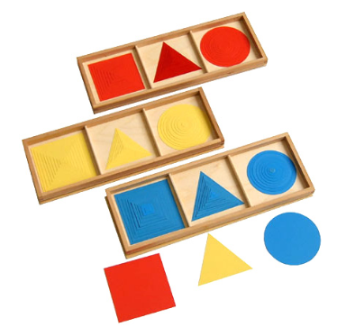

MONTESSORI AT A GLANCE

Montessori classrooms are beautifully crafted environments designed to meet the needs of children in a specific age range. Dr. Maria Montessori discovered that experiential learning in this type of classroom led to a deeper understanding of language, mathematics, science, music, social interactions and much more. Most Montessori classrooms are secular in nature, although the Montessori educational method can be integrated successfully into a faith-based program.
Every material in a Montessori classroom supports an aspect of child development, creating a match between the child’s natural interests and the available activities. Children can learn through their own experience and at their own pace. They can respond at any moment to the natural curiosities that exist in all humans and build a solid foundation for life-long learning.
All teachers, Montessori included, draw from a common source: the child and our “best practices” for teaching and learning. There are, however, unique aspects to a Montessori environment.

- Multi-year age span - (3-6 years, 6-9 years, 9-12 years)

- Individually prepared lessons - small group lessons (2-6children)

- Uninterrupted work periods (2-3 hours) during which the child schedules work Hands on materials for self-teaching

- ‘Cosmic Education’ - describes the unique Montessori curriculum which gives the child a foundational sense of perspective of the interconnectedness of the universe.

- Student Assessment - assessment based on observation, student work journals, portfolios, and meetings with teacher

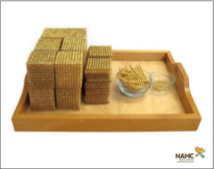

The “Whole Child” Approach
The primary goal of a Montessori program is to help each child reach full potential in all areas of life. Activities promote the development of social skills, emotional growth, and physical coordination as well as cognitive skills. Under the direction of specially trained teacher, the holistic curriculum allows the child to experience the joy of learning, gives the child time to enjoy the process, ensures the development of self-esteem and provides the experiences form which children create their knowledge.
Mixed Age Groupings
The multi-age grouping in each class provides a family-like setting where learning can take place naturally. More experienced children share what they have learned while reinforcing their own knowledge and skills. The multi-age community interaction is intrinsic to Montessori. This encourages rich language experiences, and opportunities for the development of empathy and social learning.
In order to respond to the diversity of individual children’s developmental needs, classes in the Casa and Elementary programs group children across a three-year age span. Toddler programs may have a one-year age span in order to comply with Ministry guidelines and/or the individual school’s programming.
Learning with and from each other to develop the social skills that form a class community. The social setting is like that of an extended family. The emergent skills of the individual children come together to form the class community.
The Montessori Materials
Dr. Montessori's scientific observations of the children led her to design a number of multisensory, sequential, and self-correcting materials. These facilitate learning which builds from the concrete to the abstract in constructing their knowledge.

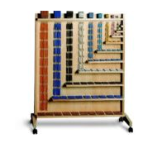
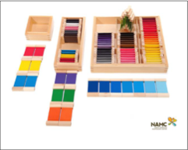

THE EMPHASIS OF MONTESSORI

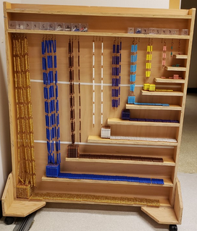
- Respect for the child
- Self-correcting learning materials and activities
- Self-motivation
- Individualized learning and instruction
- Cooperation, not competition
- Fostering independence in the child
- Responsible freedom
- Processes of learning, fostering life-long learning behaviours
- Fostering competencies based on success
- Peer assistance and teaching
- Sensory – motor preparation for intellectual development
- Stages of developmental growth (sensitive periods) and the needs of the child
- Integrated rather than compartmentalized curriculum
- Teaching conflict resolution skills
- Careful observation of the children to assess and evaluate p0erogress and plan individualized instruction _{Below}

Growth Expectations Of Children In Montessori
Enjoyment of Learning Learning through Discovery Leadership
Love of Order Confidence/Competence Responsibility
Enjoyment of Quiet Social Responsibility Independence
Self-discipline Global Awareness Cooperation
Ability to Choose Communication Self-direction

General Information
The Don Titus Montessori Program is for children aged five through twelve, Kindergarten through Grade seven. Don Titus Montessori combines three outcomes; social, personal, and work habits along with the curricular outcomes as set out by the province of British Columbia Ministry of Education. For more information visit: https://www2.gov.bc.ca/gov/content/governments/organizational-structure/ministries-organizations/ministries/education.
In addition to the BC Curriculum Montessori programs includes the following subject:
Advanced Practical Life Outdoor Education
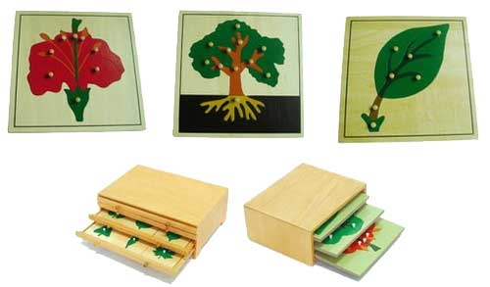

DON TITUS MONTESSORI SCHOOL STAFF

Ph: 250-788-2531

PRINCIPAL | Mrs. Bougerolle
SECRETARY | Ms. Jamie Buckley | Hours: Mon – Fri; 8:45-2:45
TEACHERS | COUNSELLING | EDUCATIONAL ASSISTANTS | INDIGENOUS EDUCATION
Ms. Dixie/Ms. Walter  Mrs. Lukey  Mrs. Pohl  Mrs. VanHorn  Ms. Laursen/Ms. Vijay  Ms. Waghela  Ms. Karavoussianis /Mrs. Buckley  Ms. Grace | Mrs. Proulx  Mr. Rand | Mrs. Armstrong  Mrs. Bedell  Mrs. Buckley  Ms. McIntyre  Mrs. Rice  Mrs. Shilson  Ms. A Collins  Ms. Manalili  Mrs. Laderoute  Ms. Williamson | Mrs. Bougerolle  Mrs. Collins

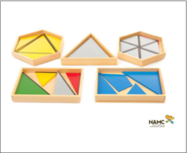

IMPORTANT THINGS TO KNOW

SCHOOL SCHEDULE

The front doors to the school are open at 8:00 am each morning.
The supervisor is outside with the children at 8:20 (when the first bus comes).

FIRST BELL 8:55 am
SECOND BELL 9:00 am
LUNCH 12:00 pm Lunch Break– Students eat lunch
12:15 pm Students go outside
12:45 pm Students come inside
DISMISSAL BELL 2:40 pm
BUSES DEPART 2:40 pm

OFFICE HOURS

8:45 am to 2:45 pm Monday through Friday
Phone messages are checked daily at 2:30 pm

IMPORTANT PHONE NUMBERS:

Don Titus Office: 250-788-2531
Bus Garage: 250-788-2415
District Board Office: 1-250-782-8571

INSIDE DAYS
Students will be inside if it is -20, or if there is a wind-chill, or if it is raining/snowing heavily. At lunch play break, we expect all students to be out on outside days. Students who are not well enough to go outside for a short while generally should not be at school.

ATTENDANCE/LATES/CHECK IN FOR SAFETY

Regular and punctual attendance is essential for a child's progress in school. If your child has to be absent, please phone the school. *As a safety check all unconfirmed absences are checked daily. If you know that your child is going to be absent or late, or if you wish to leave a message for your child, or if there are changes to the pickup of your child, please call the school directly at 250-788-2531. If the phone is not answered in person, please leave a message on our answering machine. The answering machine is checked at 2:30pm. It will be the student’s responsibility to complete assignments given during his/her absence.

IF YOU ARE TAKING YOUR CHILD OUT OF THE SCHOOL
During the school day, please fill in your information in our Student Sign Out book, kept in the office. This is part of the District’s safety protocols so that we know where all of our students are during school hours.

STUDENT SUPPLIES

Grades K-3
Kindergarten, Grades 1, 2, 3 students are provided with their supplies for a charge of $30 payable by September 30 each year. Parents will only need to provide inside shoes, a backpack and lunch kit and a water bottle.

Grades 4 – 7
Like the Primary students, Intermediate students will be provided with their supplies for a fee of $50, payable by September 30 each year. We will provide all necessary equipment such as pens, pencils, paper, duo-tangs, glue sticks. This way there is no need for parents to worry about replenishing these items as they become used up. And because we can buy in bulk, we can pass the saving on to you.

Parents will need to provide:
1 Gym strip - t-shirt & shorts. A gym bag is desirable eg: drawstring
1 Pair of inside shoes (white soled or non-marking – not black-soled shoes)
1 Lunch kit/water bottle
- Deodorant

HEALTH AND EMERGENCY CONTACTS
From time-to-time emergencies arise during school hours and we need to contact you. Please make sure we have your home number, employer's number (if applicable) and an alternative emergency number. Also, if your child’s health status changes (allergies, asthma, special needs) please let us know right away so a Safety Plan can be put in place.

LEAVING SCHOOL GROUNDS
Students are not permitted to leave the school grounds unless they are accompanied by an adult or the routinely walk home for lunch.

BUSSING
Please contact the Bus Garage at 250-788-2415 to arrange pick-up of your child or any changes to your child’s regular schedule. The bus garage will provide you with a copy of the Bus Rules.

GUEST PARKING
When you come to pick up your children after school do not drive or park in the bus loop (circular driveway) as we have buses pulling in to pick up students. Park away from the entrances. There is parking on the side of the street or on the asphalt in the marked lanes in the school area backing into a parking spot. If visiting the school during school hours, please park in the staff parking lot or parent parking lot if room is available.

TELEPHONE USE BY STUDENTS
Students will have access to a phone in the office for certain situations, like forgotten homework or a missing lunch. They will not be allowed to call home to make after school plans with their friends. CELL PHONE USE BY STUDENTS WILL NOT BE PERMITTED ON SCHOOL GROUNDS. If you need to contact your child please call the office.

PARENTS' ADVISORY COUNCIL
Don Titus has been fortunate to have enthusiastic, supportive parents. Parents bring their suggestions on school plans, policies & practices to monthly PAC meetings. All parents are entitled and encouraged to attend all meetings. Please read our weekly memos for dates and times. Our Parent Advisory Council may run a hot lunch program for students on Fridays.

PARENT VOLUNTEERS
Parents of pupils are encouraged to participate in school activities in a number of capacities. Parents can help the school by volunteering to sponsor extra-curricular activities, volunteering to help tutor pupils in the classrooms. Parents can also be of assistance in fundraising, trips, etc., that will occur during the year. To volunteer your time, contact your child’s teacher or Mrs. Bougerolle.

Criminal Record Check must be on file with the School District Office for any parents and/or guardians who volunteer. Criminal record checks must be updated every three years. Volunteer drivers must also have a current driver’s abstract on file at the school. Driver’s abstracts must be updated every 12 months. There is currently no fee for either the criminal record check or the driver’s abstract.

GUIDELINES FOR VOLUNTEERS
There is a Volunteer Package and Application that must be completed before volunteering for any school event or activity. Please see the office for a package. It contains information regarding School District Policies.

TOYS AND VALUABLES
Kids love their toys, but they are a distraction in the classroom. If students choose to bring toys to school, the toys are to be stowed out of sight in backpacks during the school day and can be taken outside at lunch. We encourage students not to bring items of value to school because there is always the chance of loss or damage and the school will not be held responsible for such loss or damage. Toys seen during instructional time will be safely stored by the teacher until after school.

LOST AND FOUND
If your child is missing any items, please have them check the LOST AND FOUND which is located just outside the office door. *Please mark all your child's possessions with his/her name.

LITTER IN SCHOOL AND ON THE GROUNDS
We do not allow students to take food wrappings outside onto the playground. Our students can feel proud of the way they keep our school clean.

COMMUNICATIONS: PARENT TO SCHOOL
If you have any concerns about your child, you are urged to contact your child's teacher right away to discuss your concern. If you need further support, please contact Mrs. Bougerolle (Principal).

REPORTING STUDENT PROGRESS TO PARENTS
In accordance with the School Act, parents receive five reports a year, three formal and two informal.

We plan the following:

November…………………. Parent/Teacher Interviews
December…………………. Learning Update
February…………………… Parent/Teacher Interviews
March.……………………. Learning Update
June……………………… Summary of Learning

The teaching staff carefully uses a fair assessment policy to document learning.

WEEKLY MEMO
A weekly memo is emailed every Sunday to each family in the school. Please ensure the school has an updated email address for your family.

SAFETY PROCEDURE FOR STUDENTS WITH ANAPHYLACTIC NEEDS (A PHYSICIAN DIAGNOSED ALLERGY OR MEDICAL CONDITION.

THE FOLLOWING AREAS OF THE SCHOOL WILL BE PEANUT AND TREE NUT FREE STARTING SEPTEMBER 2025.

- K/1 CLASSROOM (ROOM 3)
- GRADE 4/5/6 CLASSROOM (ROOM 2)
- WEST SIDE HALLWAY AND OFFICES
- KITCHEN
- LIBRARY
- GYM
- MAIN OFFICE
- MAKERSPACE

Process and monitoring:
• At the beginning of each new year and when a new student registers, the pictures of the children with anaphylactic needs are viewed by the staff and individual needs and protocols are discussed.
• Public Health Nurse is accessed if training of staff is needed to address specific needs.
• Protocol for each child is identified and shared with staff.
• Medicine if required, is kept in a safe place in the office and administered, as directed by physician.
• Crisis management and emergency response phone numbers, including the school’s address, are placed by each phone in the school.
• The school endeavors to make the school environment safe for children with specific needs.

Don Titus Montessori

Code of Conduct

2025/26

CODE OF CONDUCT 2025/26

Our Code of Conduct is designed to provide guidelines for appropriate student behaviour while under the jurisdiction of the school or at any school-sponsored function.

PROHIBITED GROUNDS OF DISCRIMINATION:

In accordance with the “prohibited grounds of discrimination set out in the BC Human Rights Code (RSBC 1996, C.210)”.

- Students will not discriminate against others on the basis of race, colour, ancestry, place of origin, religion, marital status, family status, physical or mental disability, sex, sexual orientation, gender identity or expression, and age, or for any other reason set out in the Human Rights Code of British Columbia.

- Neither will a student make gestures, publish, or display anything that would indicate an intention to discriminate against an individual or group, or expose them to contempt or ridicule on the basis of race, colour, ancestry, place of origin, religion, marital status, family status. Physical or mental disability, sex, sexual orientation, gender identify or expression, and age, or for any other reason set out in the Human Rights Code of British Columbia.

RATIONALE

- To promote a safe, caring and orderly learning environment for all students. We believe in respecting and valuing all people and voices and providing engaging learning opportunities for the students in our school. Our expectations are that students will maintenance an attitude that is cooperative, courteous and respectful.

Students of the school have rights and responsibilities

Their rights are:
- a good education
- to be treated with respect
- a clean and safe environment free from discrimination
- privacy and personal space
Their responsibilities are:
- to develop and maintain good study habits
- to respect the rights of others
- to maintain a clean and safe environment
- to treat others well, both physically and emotionally
Some Examples of Acceptable Behaviour:
- Socially responsible (polite, wait turn, listen appropriately)
- Empathetic - learning to take the perspective of others
- Active participant in learning
- Expressing concerns and needs/ listening to the concerns and needs of others
- Giving and receiving respect
- Enthusiastic
- Helpful
- Trustworthy and honest
- Caring for/advocating for self and others
- Safe use of playground and other equipment

BE SAFE and BE RESPECTFUL to YOURSELF, to OTHERS and to PROPERTY.

Some Examples of Unacceptable Behaviour:

- Verbal or physical aggression
- Rudeness or swearing
- Sexual or violent/dangerous behaviour to self or others (throwing objects such as sticks, rocks, snowballs etc.)
- Gangs
- Defiant behaviour, insolence, lack of respect, teasing
- Misusing or damaging property or equipment
- Use or possession of intoxicating or banned substances (including vape products)

SAFE AND CARING SCHOOL ENVIRONMENTS

Are Free from Acts Of
- Bullying, cyber-bullying, harassment, and marginalization
- Threat and intimidation
- Violence in any form
- Abuse in any form
- Discrimination in any form
- Retribution against anyone who reported an incident

Do Not Tolerate the Misuse Of
- Cyberspace, Cell Phones, Electronic Devices, Computers, or School Property

Do Not Tolerate the Presence Of
- Theft or vandalism
- Intoxicating or banned substances (including vape products)
- Weapons or replica (toy) weapons and explosives
- Intruders or trespassers

Consequences:
Consequences will be applied in a fair and consistent manner, respecting individual rights, responsibilities, age and maturity; and be restorative rather than punitive in nature.

Inappropriate Behavior Typically Has the Following Consequences:
- Review of expectations and a timeout
- Review of expectations, written assignment and/or loss of privileges
- Parents are informed
- Meeting with parents
- Possible short-term (in school or at home) suspension up to 5 days
- Possible change in schedule or program
- Consultation with police and/or fire department
- Expulsion
- Restorative practices (restorative conversation, circle and/or conference)
- Work with staff and family to develop a plan to address the behavior

SCHOOL FIELD TRIPS
As funds permit, it is our policy to encourage Field Trips that are educationally worthwhile.

When Field Trips are proposed a letter will be sent home describing the activity. For all field trips off the school grounds, a signed permission slip must be completed and returned to the school to enable your child to participate.

It is our feeling that a teacher should not have to deal with disruptive students on such occasions nor should other students have their trip spoiled by such students. Consequently, if a teacher feels that a student has shown by his/her behaviour at school that he/she may not be trusted to behave appropriately on a trip, that student will be assigned with work to another class for the duration of the trip. Parents will be informed ahead of time.

Students should be aware that they may be subject to discipline (or, if applicable confiscation of personal property) for misuse of technology if it negatively impacts on the school environment.

RESTRICTIONS ON STUDENT USE OF PERSONAL DIGITAL DEVICES (Updated)
The following expectations must be met:
- As needed, all students will have access to school/district owned technology at an age-appropriate level that supports learning and the development of digital literacy.
- As outlined in an Inclusive and Competency-Based Individual education Plan (ICBIEP), schools will exempt specific students form restrictions on the use of personal digital devices when they are needed to support inclusion in learning.
- Additionally, schools will exempt specific students from restrictions on the use of personal digital devices when they are needed as an essential support for medical plan and needs (i.e. diabetes, medication, etc.).
- Personal digital devices at the elementary school level will not be permitted at any time during the school day.
- The security and storage of personal digital devices is the sole responsibility of the owner/user. The District assumes no responsibility for the safety, security, loss, repair or replacement of such devices.
*Personal digital devices include but are not limited to, cellphones, smartphones, tablets, computers, smartwatches, Bluetooth headphones, and portable video game systems.

STUDENT DRESS CODE
Students are expected to dress appropriately for school, winter and summer. The general rule for the dress code is for students to dress in a manner appropriate to establish a positive learning atmosphere at school. This means that clothes that may be appropriate in other settings may not be appropriate for school.
School administration reserves the right to judge what is or is not appropriate.

The following is agreed upon by staff, administration, and students to provide guidelines around appropriate dress at school.

- Footwear must, for safety reasons, be worn at all times.
- Clothing of any kind condoning violence, profanity, hatred, discrimination, negative stereotypes, or promoting illegal drug use or abuse of alcohol are not appropriate.

Accommodation of Students with Diversabilities:

Special consideration may apply to students who are unable to comply with the Code of Conduct due to a disability of an intellectual, physical, sensory, emotional or behavioural nature.

Notification
As circumstances warrant, administrators have a responsibility to advise other parties following a behaviour incident:
- Parent of student exhibiting major behaviours (in every instance)
- Parent of student (if any) on the receiving end (in every instance)
- Superintendent, Safe Schools Team Member and/or other District Staff
- Ministerial agencies and/or School Liaison Officer (Police)

Don Titus Montessori School Code of Conduct has been structured to align with and adhere to the standards outlined in:
- The School Act
- B.C. Human Rights Code
- B.C. Ministry of Education: Safe, Caring and Orderly Schools Guide (2014)

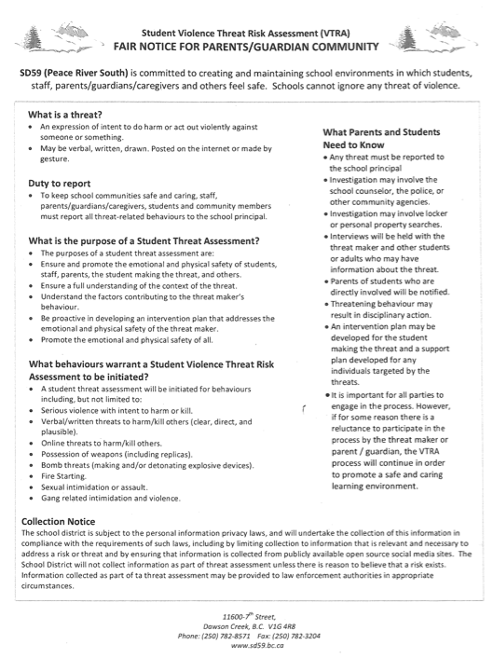
FAIR NOTICE
School District 59 Calendar 2025/2026

Tuesday, September 2 Non-Instructional Day: Curriculum Implementation Day
Wednesday, September 3 First Day for Students (arrival 2 hours late, dismissal 1 hour early)
Tuesday, September 30 National Day for Truth and Reconciliation STAT
Monday, October 13 Thanksgiving Day STAT
Mon & Tues, Oct. 27 & 28 Non-Instructional Days: Professional Development (Conference/District)
Tuesday, November 11 Remembrance Day STAT
Wed & Thurs, Nov 19 & 20 Early Dismissal (1h) for Parent Interviews
Friday, November 28 Non-Instructional Day: Professional Development (School)
Dec 22 to Jan 2 Winter Break (Collective Agreement language - Winter Break
starts on the Monday directly preceding Boxing Day)
Monday, January 5 Schools Reopen
Friday, January 30 Non-Instructional Day: Professional Development (School)
Monday, February 16 Family Day STAT
Wed & Thurs, Feb 25 & 26 Early Dismissal (1h) for Parent Interviews
March 16 to March 27 Spring Break (Collective Agreement language - Spring Break
starts on the third Monday in March)
Monday, March 30 Schools Reopen
Friday, April 3 Good Friday STAT
Monday, April 6 Easter Monday STAT
Friday, May 1 Non-Instructional Day: Truth and Reconciliation
Monday, May 18 Victoria Day STAT
Monday, June 1 Non-Instructional Day: Professional Development (School)
Thursday, June 25 Last Day of Attendance for Students
Friday, June 26 Non-Instructional Day: Year End Administrative Day

Notes
Kindergarten - required hours of instruction 853 minimum to allow for gradual entry in September
Elementary - required hours of instruction 878 minimum required 4 hours 55 minutes per day
Secondary - required hours of instruction 952 minimum required 5 hours 20 minutes per day
Total Instructional Days: 179

Elementary Terms
Term 1 Sept 3 to Dec 5 (62 instructional days)
Term 2 Dec 8 to Mar 13 (58 instructional days)
Term 3 Mar 30 to June 25 (59 instructional days)
Secondary Semesters
Semester 1 Sept 3 to Jan 29 (91 instructional days)
Semester 2 Feb 2 to June 25 (88 instructional days)

PRINCIPAL’S MESSAGE

Welcome to the 2025/26 school year!

Whether you are new to Don Titus or returning, we are so happy to have you as part of our learning community.

We are looking forward to an engaging year of educating and providing fun and meaningful learning experiences for students. One of our focusses this year is going to be on increasing family and community engagement in the school. We will be reaching out with many opportunities for you to become involved in your child’s learning, including parent education nights, volunteering for field trip supervision, helping with practical life skills like cooking and sewing, and general classroom support with reading and math facts. Please consider donating some of your time to enrich the experience for all students at Don Titus.

The staff and I look forward to an exciting year at Don Titus Montessori.

Sincerely,

Sincerely,

Jody Bougerolle
Principal


“The greatest gifts we can give our children are the roots of responsibility and the wings of independence.”

__________Maria Montessori __________

Resources Cited

Montessori Northwest Resources tab – What is Montessori Education? Bottom Quote https://montessori-nw.org/what-is-montessori-education Visited June 6, 2019
Principles of the Montessori Method https://www.education.com/download-pdf/reference/26190/ Visited June 6, 2019.
Parkside (Grande Prairie AB) Montessori Family Handbook 2018-2019
CCMA (The Canadian Council of Montessori Administrators, http://www.ccma.ca/what-makes-it-unique, Visited June 6, 2019.
PGMES_Brochure_SM_fnl.pdf (Prince George Montessori Education Society Brochure https://pgmontessori.ca/montessori-materials/
PGMES Brochure, https://drive.google.com/drive/folders/0B_aM8FQx83XINl9EVXBVUFVpN3c Visited June 6, 2019 http://www.ccma.ca/how-does-it-work Visited June 6, 2019
Parkside (Grande Prairie AB) Montessori Family Handbook 2018-2019 Photos: NAMC, https://www.montessoritraining.net/, Prince George Montessori Education Society, https://pgmontessori.ca/montessori-materials/, Visited June 6, 2019. Parent & student acknowledgement of the PARENT & STUDENT HANDBOOK ACTION: Signature Required Return this signed page only to the school. Parents, please review this document and discuss it with your child(ren). I, __________________________________ (print your name), the legal parent/guardian of, ___________________________________ (print student/student’s FAMILY name) ____________________________________ (Student/Students’ Initials) I AM REQUESTING PARENT CONSULTATION ON THE CODE OF CONDUCT. PLEASE PROVIDE SUGGESTIONS OR AREAS YOU’D LIKE TO SEE CHANGED IN WRITING BY EMAIL TO JBOUGEROLLE@SD59.BC.CA. IF YOU ARE SATISFIED WITH THE CURRENT CODE OF CONDUCT PLEASE SIGN AND RETURN THIS PAGE. ______________________________________ __________________________ Parent Signature Date 

