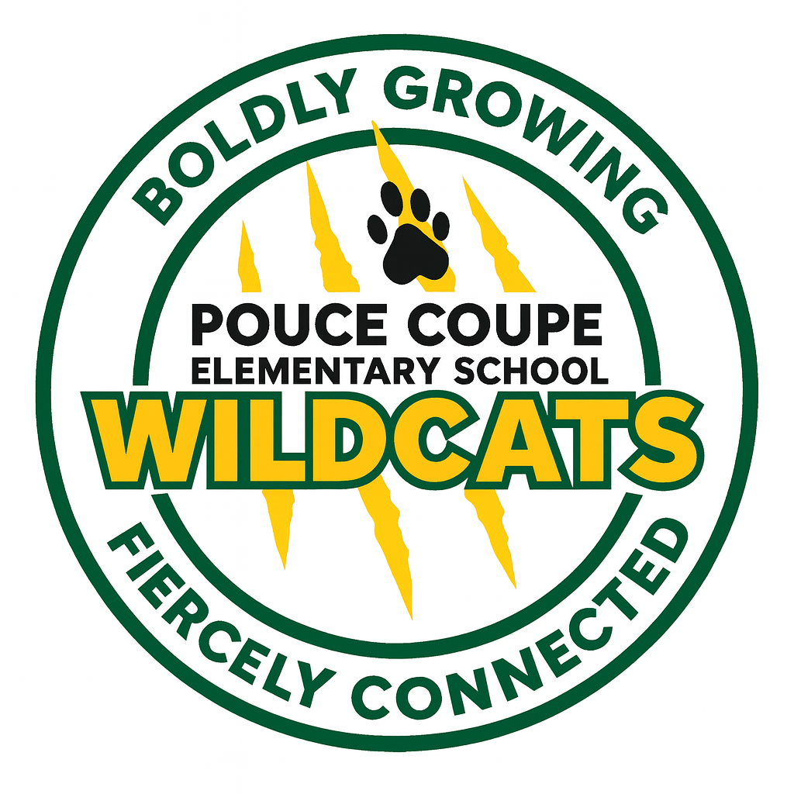
CODE OF CONDUCT
2026/27

Purpose
This Code of Conduct promotes a safe, caring and orderly learning environment for all students. We respect and value all people and voices, and we provide engaging learning opportunities for the students in our school. Students are expected to be cooperative, courteous and respectful.
It provides guidelines for appropriate behaviour for all members of the school community, including students, parents and staff.

Where the Code Applies
These expectations apply to:
- Behaviour at school and during school-organized or school-sponsored activities.
- Behaviour beyond these times—including online behaviour—that negatively affects the school’s safe, caring or orderly environment and/or student learning.

Reporting Serious Breaches
If a serious breach occurs, school officials may be responsible for advising other parties, including parents, school district officials, police, the Ministry of Children and Family Development and/or other agencies.
Students need to feel comfortable reporting any breach to a trusted adult in a timely manner. Retribution against anyone who reports an incident is unacceptable and will be treated seriously.

Prohibited Grounds of Discrimination
In accordance with the “prohibited grounds of discrimination set out in the BC Human Rights Code (RSBC 1996, c. 210),” students will not discriminate against others because of race, colour, ancestry, place of origin, religion, marital status, family status, physical or mental disability, sex, sexual orientation, gender identity or expression, age, or for any other reason set out in the Human Rights Code of British Columbia.
Students will also not make gestures, publish or display anything that indicates an intention to discriminate against an individual or group—or expose them to contempt or ridicule—on any of these grounds.

Examples of Acceptable Behaviour
Setting | What this looks like
In the classroom | - Be kind.  - Use an inside voice.  - Keep hands to ourselves.  - Try our best.  - Take care of our things.  - Listen to others.
In the hallways | - Be quiet.  - Walk in line.  - Keep our hands to ourselves.  - Do not play.
On the playground | - Take turns and include others.  - Leave rocks, sticks and snow on the ground.  - Keep the ground free of litter.  - Keep hands to ourselves.  - Use kind language.
In the washrooms | - Clean up our messes.  - Respect others’ privacy.  - Be kind to others.  - Keep our hands to ourselves.  - Do not play.
BE SAFE and BE RESPECTFUL—to YOURSELF, to OTHERS and to PROPERTY.

Examples of Unacceptable Behaviour
- Verbal or physical aggression.
- Rudeness or swearing.
- Physically dangerous behaviour toward self or others, including throwing objects such as sticks, rocks or snowballs.
- Defiant behaviour, insolence, lack of respect or teasing.
- Misusing or damaging property or equipment.

Safe and Caring School Environments
Safe and caring school environments are free from acts of:
- Bullying, cyber-bullying, harassment and marginalization.
- Threat and intimidation.
- Violence in any form.
- Abuse in any form.
- Discrimination in any form.
- Retribution against anyone who reported an incident.

Misuse of Technology
The misuse of cyberspace, cell phones, electronic devices and computers will not be tolerated.
Students are not permitted to use personal cell phones or electronic devices from the time they arrive on school grounds until the time they leave. Students who bring devices to school will be asked to place them in the office and retrieve them at the end of the day. If problems continue, a parent or guardian will be required to pick up the device from the office.

Items and People Not Permitted
The following will not be tolerated:
- Theft or vandalism.
- Intoxicating or banned substances.
- Weapons, replica (toy) weapons and explosives.
- Intruders or trespassers.

Consequences for Inappropriate Behaviour
Inappropriate behaviour typically has the following consequences, not necessarily in the order listed:
- Review of expectations and a timeout.
- Review of expectations, a written assignment and/or loss of privileges.
- Parents are informed.
- A meeting with parents.
- Restorative practices, including a restorative conversation, circle and/or conference.
- Working with staff and family to develop a plan that addresses the behaviour.
- Possible short-term suspension—in school or at home—for up to five days.
- Possible change in schedule or program.
- Consultation with police and/or the fire department.
- Expulsion.

Rising Expectations
As students mature, expectations for their behaviour will change. There will be:
- Increasing personal responsibility and self-discipline.
- Increasing consequences for inappropriate conduct or unacceptable behaviour.
Fair, consistent and restorative responses. Consequences will be applied fairly and consistently, with respect for individual rights, responsibilities, age and maturity. They will be restorative rather than punitive in nature.
Special considerations. There may be times when special considerations apply to students with special needs who are unable to meet expectations because of a disability of an intellectual, physical, sensory, emotional or behavioural nature.

